**DESIGN AND CONSTRUCTION OF AN ELECTRONIC WIRELESS DISTANCE MEASUREMENT INSTRUMENT**

**BY**

**MUSA Mohammed Mahdi**

**(ET/EE/HND/20/022)**

**A PROJECT REPORT SUBMITTED IN PARTIAL FULFILMENT**

**OF THE REQUEMENT FOR THE AWARD OF HIGHER NATIONAL DIPLOMA IN**

**ELECTRICAL AND ELECTRONIC ENGINEERING**

**DEPERTMENT OF ELECTRICAL AND ELECTRONIC ENGINEERING**

**TECHNOLOGY, FEDERAL POLYTECHNIC MUBI.**

**SEPTEMBER, 2023**

# DEDICATION

I dedicate this work to God almighty for his grace and mercy upon my life and to my parents for their care, prayers and support.

# DECLARATION

I hereby declare that the project work entitled “Design and Construction of Electronic Wireless Distance Measurement Instrument” was written by me MUSA Mohammed Mahdi**.** It is my record of work; The work has not been presented or submitted elsewhere for consideration of degree/diploma/certificate award. All references made to published literatures have been duly acknowledged.

Signature………………………. Date……………………

**MUSA Mohammed Mahdi**

(ET/EE/HND/20/022)

# CERTIFICATION

This is to certify that this project work “Design and Construction of Electronic Wireless Distance Measurement Instrument” presented by MUSA Mohammed Mahdi has been written in accordance with regulations governing the preparation and presentation of projects in the Federal polytechnic Mubi and meets the requirements for the award of Higher National Diploma in Electrical and Electronics Engineering Technology.

Signature…………………………….. Date………………………………..

**MUSA Mohammed Mahdi**

(ET/EE/HND/20/022)

Signature…………………………… Date………………………………..

**Mr. Ijafiya J. Medugu**

(Project Supervisor)

# APPROVAL PAGE

This project report entitled “Design and Construction of Electronic Wireless Distance Measurement Instrument” presented by MUSA Mohammed Mahdi was submitted to the Department of Electrical and Electronics Engineering Technology and has been accepted as partial fulfilment of the requirement for the award of Higher National Diploma in Electrical and Electronics Engineering Technology. Federal polytechnic, Mubi.

Signature…………………………… Date……………………………

**Mr. Ijafiya J. Medugu**

(Project Supervisor)

Signature…………………………… Date……………………………

**Engr. Victor O. N.**

(Head of Department)

Signature…………………………… Date……………………………

E**ngr. Muhammad Aliyu Gadam Ph.D**

(External Supervisor)

# ACKNOWLEDGMENTS

I want to acknowledge Almighty God for his infinite mercy and protection throughout our academic activities. And for the understanding in achieving my academic success.

I also recognize my Supervisor Mr. Ijafiya J. Medugu for his untiring and useful comments, support, guidance and suggestions he provided to critically review the manuscripts to effect the necessary corrections throughout this research work. I am very happy to acknowledge his zealous efforts.

My sincere appreciations and thanks go to the Head of Department Engr. Victor O. Nkeleme for his moral encouragement throughout my period of study. I also acknowledge all Staff of Electrical Electronics Engineering Technology, Federal Polytechnic, Mubi for all their sacrificial commitments in the process of imparting academic knowledge on me.

I wish to extend my hearty acknowledgment of gratitude to my dear uncle, my mother and my entire family members.

Finally, I appreciate the efforts of my friends and relatives, course mates and all well-wishers. I love you all, may the Almighty God bless you abundantly, Amen.

# ABSTRACT

*A distance dictator is any dictator capable of measuring the distance between two points. The origin or distance measurement by means of graduated length of material such as chain, tape measure or piece of knot rope are lost to antiquity. Before now, engineers never produced a range finder module but in the end they find out the module have many disadvantage like limitation for distance, different result for different color obstacle and need a calibration each time before using it, manual distance measuring is always done at the expenses of human error, practice and fix measure of low range distance, is the main object for this project. The ultra-sonic distance motor operate in a way that when sound signal send by the transmitter part of the sensor gets Echo back to the receiving part of the sensor. The micro controller is programmed to calculate the time taken by the waves to travel to obstacle and back, is calculated by the micro controller and display the result of the LCD (liquid Crystal Display) screen in centimeter.*

# TABLE OF CONTENT

Contents Page

TITLE PAGE i

DEDICATION ii

DECLARATION iii

CERTIFICATION iv

APPROVAL PAGE v

ACKNOWLEDGMENTS vi

ABSTRACT vii

TABLE OF CONTENT viii

LIST OF TABLES x

LIST OF FIGUERS xi

CHAPTER ONE 1

INTRODUCTION 1

1.1 Background of The Study 1

1.2 Statement of The Problem 2

1.3 Aim and Objectives 3

1.4 Significance of The Study 3

CHAPTER TWO 4

LITERATURE REVIEW 4

2.1 Review of Related Work 4

2.2 Theoretical review 7

2.2.1 Measurement 7

2.2.2 Measuring Instrument 8

2.2.3 Types of Measuring Instruments 8

2.2.3.5 Smart and non-smart instruments 12

2.3 Ultrasonic Sensor for Distance Measurements 12

2.4 The Microcontroller for Distance Measurement 13

2.4.1 Communication 14

2.4.2 Programming 15

2.4.3 Automatic (Software) Reset 15

2.5 The Display 16

3.2 Methods 19

3.3 The Microcontroller 19

3.4 The Display 19

3.5 The Sensor 19

3.6 Principle of Operation 20

3.7 Construction 21

3.7.1 Bread boarding 21

3.7.2 Soldering 22

3.8 Testing 23

3.8.1 Component Testing 24

3.8.2 Complete Prototype Testing 24

CHAPTER FOUR 25

TESTING, RESULT AND DISCUSSION 25

4.1 Result 25

4.2 Discussion 26

CHAPTER FIVE 28

SUMMARY, CONCLUSION AND RECOMMENDATIONS 28

5.1 Summary 28

5.2 Conclusion 28

5.3 Recommendations 29

REFERENCES 30

APPENDIX 31

# LIST OF TABLES

**TABLE Page**

Table 3.1: List of components ………………………………………………….…………. 20

Table 4.1: Component Test Result………………………………………………….……... 27

Table 4.2: Result of Measurement with Ruler/3m Tape …………………………………... 28

Table 4.3: Bill of Engineering Measurement and Evaluation (BEME)……………………. 29

# LIST OF FIGUERS

**FIGURE**  **Page**

Figure 2.1: Ultrasonic sensor (incident and Reflection wave) diagram……………………. 14

Figure 2.2: Diagram of the Ultrasonic sensor…………………………………………….... 15

Figure 2.3: The lcd display connections…………………………………………….…... 18

Figure 2.4: The LCD features……………………………………………………………... 19

Figure 3.1: Block diagram of the ultrasonic distance meter……………………………...... 21

Figure 3.2: Complete Circuit Diagram…………………………………………………...... 22

Figure 3.3: Breadboard Layout……………………..……………………………………... 23

Figure 3.4: Soldering………………………..……………………………………………... 25

Figure 3.5: the soldered circuit………………...…………………………………………... 25

Figure 3.6: The prototype test Setup………..……………………………………………... 26

# CHAPTER ONE

# INTRODUCTION

## 1.1 Background of The Study

Nowadays, we have some difficulties in obtaining the distance that we want to measure. Even though, measuring tape is an easy option, but this kind of tool can have some limitation of measuring time or manual errors. Before now, engineers have produced a range finder module, but, in the end, they find out the module have many disadvantages like limitation for distance, different result for different colored obstacles, and need a calibration each time before using it. Manual distance measuring is always done at the expense of human error. Precise and fix measurement of low range distance, is the main objective for this project.

A distance detector is any device capable of measuring the distance between two points. The origins of distance measurement by means of graduated lengths of material such as chain, tape measure or piece of knotted rope are lost to antiquity. Optical distance measurement also has a long history, and is usually taken to stem from the work of James Watt in 1771. Electro-magnetic measurements make up a third method, where the time of travel of radio or light waves is converted into a distance. Since James Watt, hundreds of different types of instrument have been produced to make indirect distance measurement using light. All kinds of devices or equipment nowadays, begin with the basic design, basic theory and then all the weakness followed by improvement step by step. So, this project will also do right the same reason which the improvement will be applied to bring the advantages to the user when measuring the distance depending on several problems that had been identified. Ultrasonic technology is one of the medium on how the distance will be measure and this is one of the ways that the world today widely used especially in some kind of general application such as warfare applications, engineering applications and also in scientific and medical applications. Basically, this ultrasonic technology is based on ultrasound and a common use of ultrasound is in range finding that perfectly related to the objectives of this project. This technology can be used for measuring: wind speed and direction (anemometer), fullness of a tank, and speed through air or water. For measuring speed or direction, a device uses multiple detectors and calculates the speed from the relative distances to particulates in the air or water. To measure the amount of liquid in a tank, the sensor measures the distance to the surface of the fluid.

An ultrasonic sensor houses a transducer that emits high-frequency, inaudible acoustic waves in one direction when the transducer element vibrates. If the waves strike and bounce off an object, the transducer receives the echoed signal. The sensor then determines its distance from the object based on the length of time between the initial sound burst and the echo's return. Ultrasonic sensors require fairly accurate timing circuitry, so acoustic sensors really require a processor of some sort to drive them. Ultrasonic sensors should be a first choice for detecting clear objects, liquids, dense materials of any surface type (rough, smooth, shiny) and irregular shaped objects. This makes them one of the most ideal choices for measuring the height of containers which could be of different shapes, sizes, color and material.

## 1.2 Statement of The Problem

Current distance measurement methods often require wired connections between sensors and data collection units, limiting flexibility and hindering mobility. A wireless solution is needed to eliminate these constraints and enable remote monitoring and control.

Accuracy and Precision: Many existing wireless distance measurement systems compromise accuracy and precision for the sake of portability. There is a need for a system that delivers reliable and high-precision distance measurements across a wide range of applications.

Real-Time Data: Industries such as robotics and autonomous vehicles demand real-time distance data to make instant decisions and avoid collisions. The lack of accessible real-time distance measurement solutions impedes the progress of these industries.

## 1.3 Aim and Objectives

The aim of the project is to design and construct an instrument that would use ultrasonic technology to determine upto 10m distance between the device and an object. The objectives are as follows:

1. To design a 10meter ultrasonic distance detector using Arduino microcontroller.
2. To write a program in c++ language that would direct the functioning of the microcontroller.
3. The objective of this work is to replace the old traditional physical ruler used in several applications.

## 1.4 Significance of The Study

This work is significant as it automated the distance measuring process, one need only point at the target area and distance is established without the need for manual laborious human intervention. Secondly in the area of precision the device offers more precision than the manual mode of distance measurement. Thirdly errors are reduced with the use of this system because human estimate which is prone to parallax and other errors is eliminated.

**1.5 Scope and limitations of The Study**

This study will be limited to the design and construction of an Arduino based ultrasonic distance meter, the program written will be in c+ language, the hardware components will be selected and not manufactured. The maximum distance to be measured will be limited to the maximum distance the selected ultrasonic detector can sense (which is 3meter). Power will be from Dc 12V battery so as to make the device portable. The device will be programmed from the Arduino IDE on windows 10 platform only.

# CHAPTER TWO

# LITERATURE REVIEW

## 2.1 Review of Related Work

Mohammed (2015), designed and constructed a smart distance measuring device using an ultrasonic sensor and a pic 16F84A and a lcd display for visual display of readings. The work was incorporated a storage device for storage of four measurements. A key was provided for store and recall of data. This work was very successful as it was able to measure with accuracy, store and retrieve store measurement data.

Shamsul (2013), designed and constructed an ultrasonic distance meter where it was stated that There are several ways to measure distance without contact. One way is to use ultrasonic waves at 40 kHz for distance measurement. Ultrasonic transducers measure the amount of time taken for a pulse of sound to travel to a particular surface and return as the reflection echo.

This circuit calculates the distance based on the speed of sound at 25°C ambient temperature and shows it on LCD display. Using it, we can measure distance up to 2.5 meters. In this circuit, a 40 kHz transducer is used for measurement in the air medium. In this project, the ultrasonic transmitter unit was excited with a 40 kHz pulse burst and expect an echo from the object whose distance we want to measure. It travels to the object in the air and the echo signal is picked up by another ultrasonic transducer unit (receiver), also a 40 kHz pre-tuned unit. The system consists of main components, a Display, a Tranducer and a microcontroller unit which acts as the brain of the system. Input and output components such as transmitter unit, receiver circuit, temperature control and LCD modules are connected to the system brain. The transmitter generates a 40 kHz signals and begin the transmission time together with the process of sending signals. While the signals begin to transmit through ultrasonic transducer, the microcontroller will capture the starting point of transmission time and hold it until the receiver gets the echo signal back. The signal will contact with any obstacle ahead and will bounce back to the receiver circuit. When the signal is back, the receiver must detect the echo signal, process & send to the microcontroller. The microcontroller will stop the transmission time immediately and will calculate the range using the transmission time and display the range on LCD modules. If the transmit signal cannot touch any obstacle in front of it, or the time is very fast, the system will display error message on the LCD modules, indicating that the range is not suitable for the system. The system worked well but it was very expensive and the program written was very complex.

Monisha *et al.* (2012) worked on a smart distance measuring device using ultrasonic principles, where it was stated that Distance measurement plays a vital role in engineering, science, business. The distance is always measured between two points. Generally, distance measurement is possible only by making contact with the target whose distance is to be measured, but this paper discusses the measurement of distance without making contact with the target. This is done by generating 40 kHz ultrasonic waves using ultrasonic transducers. Here the distance is calculated on the basis on time taken by the pulse generated by the ultrasonic transducer to travel to the target and return as reflected echo. This device also makes the use of Arduino microcontroller for calculating the distance and displaying it on a seven-segment display. The distance up to 2.5m is calculated in air medium at ambient temperature.

In conclusion the objective of the project was to design and implement an ultrasonic distance meter. The device described here can detect the target and calculate the distance of the target. The ultrasonic distance meter is a low cost, and a simple device for distance measurement. The device calculates the distance with suitable accuracy and resolution. It is a handy system for non-contact measurement of distance. The device has its application in many fields. It can be used in car backing system, automation and robotics, detecting the depth of the snow, water level of the tank, production line. This device will also have its application in civil and mechanical field for precise and small measurements. For calculating the distance using this device, the target whose distance is to be measured should always be perpendicular to the plane of propagation of the ultrasonic waves. Hence the orientation of the target is a limitation of this system. The ultrasonic detection range also depends on the size and position of the target. The bigger the target, the stronger will be the reflected signal and more accurate will be the distance calculated. Hence the ultrasonic distance meter is an extremely useful device

According to Prakhar *et al.* (2014) there are some difficulties in obtaining the distance that we want to measure. Even though, measuring tape is an easy option, but this kind of tool will have a limitation of manual error. Before this, engineers have produced a range finder module but, in the end, they find out the module have many disadvantages like limitation for distance, different result for different colored obstacles, and need a calibration for every time before one starts using it. Manual distance measuring is always done at the expense of human error. Precise and fix measurement of low range distance, is the main objective for this project. This device can measure distance in the range of 0.5m to 4m with the accuracy of1cm.This project is used to measure the distance by using ultrasonic sensors. It works by transmitting ultrasonic waves at 40 kHz. Then, the transducers will measure the amount of time taken for a pulse of sound travel to a particular surface and return as the reflected echo. After that, the circuit that have been programmed with AT mega microcontroller will calculate the distance based on the speed of sound at 25°C which an ambient temperature and also the time taken. The distance then will be display on a LCD module. The importance of the project is calculating accurate distance from any target that we want to measure. The device can be used in many different fields and categories like distance calculation in construction field, robots, car sensor to avoid obstacles and many other applications. The building process of the device was based on using as much as possible from the courses taken in the university, like Micro Processor, Basic Electrical Engineering, Multimedia and systems and Electronics Devices and also practical work in the laboratories.

## 2.2 Theoretical review

### **2.2.1** Measurement

Measurement is the assignment of a number to a characteristic of an object or event, which can be compared with other objects or events (Kirch & Wilhelm, 2008)*.* The scope and application of a measurement is dependent on the context and discipline. In the natural sciences and engineering, measurements do not apply to nominal properties of objects or events, which is consistent with the guidelines of the International vocabulary of metrology published by the International Bureau of Weights and Measures (International Bureau of Weights and Measures,2008)*.* However, in other fields such as statistics as well as the social and behavioral, measurements can have multiple levels, which would include nominal, ordinal, interval, and ratio scales (Kirch & Wilhelm, 2008*)*.

Measurement is a cornerstone for trade, science, technology, and quantitative research in many disciplines. Historically, many measurement systems existed for the varied fields of human existence to facilitate comparisons in these fields (Pedhazur & Elazar, 2019). Often these were achieved by local agreements between trading partners or collaborators (Pedhahazur & Elazer, 2019). Since the 18th century, developments progressed towards unifying, widely accepted standards that resulted in the modern International System of Units (SI). This system reduces all physical measurements to a mathematical combination of seven base units which are: kilogram, metre, candela, second, ampere, Kelvin, and mole. The first proposal to tie an SI base unit to an experimental standard independent of fiat was by Charles Sanders Peirce (1839–1914), who proposed to define the metre in terms of the wavelength of a spectral line (Crease, 2012). The metric system features a single base unit for many physical quantities. Other quantities are derived from the standard SI units. Multiples and fractions of the units are expressed as Powers of 10 of each unit. Unit conversions are always simple because they are in the ratio of ten, one hundred, one thousand, etc., so that convenient magnitudes for measurements are achieved by simply moving the decimal place: 1.234 metres is 1234 millimetres or 0.001234 kilometres (Crease 2012). The use of fractions, such as 2/5 of a metre, is not prohibited, but uncommon. All lengths and distances, for example, are measured in metres, or thousands of a metre (millimetres), or thousands of metres (kilometres) (Crease, 2012).

### **2.2.2** Measuring Instrument

Instrumentation is technology of measurement which serves not only in science but in all branch of engineering and medicine and almost every human endeavor. Measurement may be used to monitor a process. A measuring instrument exist to provide the information about the physical quantity been measured. Measuring instrument is a device for measuring a physical quantity such as length, weight, temperature, current etc. The instrument indicates the value of the quantity which helps one to take appropriate action and decision (Kirch & Wilhem, 2008).

### **2.2.3** Types of Measuring Instruments

Instruments can be subdivided into separate classes according to several criteria. These sub classifications are useful in broadly establishing several attributes of particular instruments such as accuracy cost and general applicability to different applications (Morris, 2011).

Instrument may be classified as active or passive instrument. They may also be classified as Null or deflection type instrument as well as Analogue or digital instruments etc.

#### 2.2.3.1 Active and Passive Instruments

Instruments are divided into active or passive ones according to whether the instrument output is entirely produced by the quantity being measured or whether the quantity being measured simply modulates the magnitude of some external power source. This is illustrated by examples.

An example of a passive instrument is the pressure measuring device. The pressure of the fluid is translated into a movement of a pointer against a scale. The energy expended in moving the pointer is derived entirely from the change in pressure measured: there are no other energy inputs to the system (Morris, 2011).

An example of an active instrument is a float type petrol tank level indicator. Here, the change in petrol level moves a potentiometer arm, and the output signal consists of a proportion of the external voltage source applied across the two ends of the potentiometer. The energy in the output signal comes from the external power source: the primary transducer float system is merely modulating the value of the voltage from this external power source. In active instruments, the external power source is usually in electrical form, but in some cases, it can be other forms of energy such as a pneumatic or hydraulic one. One very important difference between active and passive instruments is the level of measurement resolution that can be obtained. With the simple pressure gauge shown, the amount of movement made by the pointer for a particular pressure change is closely defined by the nature of the instrument (Prakhar & Jane, 2014).

In terms of cost, passive instruments are normally of a simpler construction than active ones and are therefore cheaper to manufacture. Therefore, choice between active and passive instruments for a particular application involves carefully balancing the measurement resolution requirements against cost.

#### 2.2.3.2 Null type and Deflection-Type Instruments.

The pressure gauge just mentioned is a good example of a deflection type of instrument, where the value of the quantity being measured is displayed in terms of the amount of movement of a pointer. An alternative type of pressure gauge is the deadweight gauge, which is a null-type instrument. Here, weights are put on top of the piston until the downward force balances the fluid pressure. Weights are added until the piston reaches a datum level, known as the null point. Pressure measurement is made in terms of the value of the weights needed to reach this null position. The accuracy of these two instruments depends on different things. For the first one it depends on the linearity and calibration of the spring, while for the second it relies on the calibration of the weights. As calibration of weights is much easier than careful choice and calibration of a linear characteristic spring, this means that the second type of instrument will normally be the more accurate. This is in accordance with the general rule that null type instruments are more accurate than deflection types (Morris, 2011). In terms of usage, the deflection type instrument is clearly more convenient. It is far simpler to read the position of a pointer against a scale than to add and subtract weights until a null point is reached. A deflection-type instrument is therefore the one that would normally be used in the workplace. However, for calibration duties, the null type instrument is preferable because of its superior accuracy. The extra effort required to use such an instrument is perfectly acceptable in this case because of the infrequent nature of calibration operations (Morris, 2011).

#### 2.2.3.3 Analogue and Digital Instruments

An analogue instrument gives an output that varies continuously as the quantity being measured changes. The output can have an infinite number of values within the range that the instrument is designed to measure. The deflection-type of pressure gauge described earlier in this chapter is a good example of an analogue instrument. As the input value changes, the pointer moves with a smooth continuous motion. While the pointer can therefore be in an infinite number of positions within its range of movement, the number of different positions that the eye can discriminate between is strictly limited, this discrimination being dependent upon how large the scale is and how finely it is divided (Morris, 2011). A digital instrument has output that varies in discrete steps.

The distinction between analogue and digital instruments has become particularly important with the rapid growth in the application of microcomputers to automatic control systems. Any digital computer system, of which the microcomputer is but one example, performs its computations in digital form. An instrument whose output is in digital form is therefore particularly advantageous in such applications, as it can be interfaced directly to the control computer. Analogue instruments must be interfaced to the microcomputer by an analogue-to-digital (A/D) converter, which converts the analogue output signal from the instrument into an equivalent digital quantity that can be read into the computer. This conversion has several disadvantages. Firstly, the A/D converter adds a significant cost to the system. Secondly, a finite time is involved in the process of converting an analogue signal to a digital quantity, and this time can be critical in the control of fast processes where the accuracy of control depends on the speed of the controlling computer. Degrading the speed of operation of the control computer by imposing a requirement for A/D conversion thus impairs the accuracy by which the process is controlled (Morris, 2011).

#### 2.2.3.4 Indicating Instruments and Instruments with a Signal Output

The final way in which instruments can be divided is between those that merely give an audio or visual indication of the magnitude of the physical quantity measured and those that give an output in the form of a measurement signal whose magnitude is proportional to the measured quantity. The class of indicating instruments normally includes all null-type instruments and most passive ones (Morris, 2011). Indicators can also be further divided into those that have an analogue output and those that have a digital display. A common analogue indicator is the liquidin-glass thermometer. Another common indicating device, which exists in both analogue and digital forms, is the bathroom scale (Morris, 2011). The older mechanical form of this is an analogue type of instrument that gives an output consisting of a rotating pointer moving against a scale (or sometimes a rotating scale moving against a pointer).

More recent electronic forms of bathroom scale have a digital output consisting of numbers presented on an electronic display. One major drawback with indicating devices is that human intervention is required to read and record a measurement. This process is particularly prone to error in the case of analogue output displays, Digital displays are not very prone to error unless the human reader is careless (Morris, 2011).

Instruments that have a signal-type output are commonly used as part of automatic control systems. In other circumstances, they can also be found in measurement systems where the output measurement signal is recorded in some way for later use.

### 2.2.3.5 Smart and non-smart instruments

The advent of the microprocessor has created a new division in instruments between those that do incorporate a microprocessor (smart) and those that do not.

## 2.3 Ultrasonic Sensor for Distance Measurements

An ultrasonic sensor is an electronic device that measures the distance of a target object by emitting ultrasonic sound waves, and converts the reflected sound into an electrical signal. Ultrasonic waves travel faster than the speed of audible sound (i.e. the sound that humans can hear). Ultrasonic sensors have two main components: the transmitter (which emits the sound using piezoelectric crystals) and the receiver (which encounters the sound after it has travelled to and from the target).

In order to calculate the distance between the sensor and the object, the sensor measures the time it takes between the emission of the sound by the transmitter to its contact with the receiver. The formula for this calculation is [D = ½ T x C](https://www.arrow.com/en/research-and-events/articles/ultrasonic-sensors-how-they-work-and-how-to-use-them-with-arduino) (where D is the distance, T is the time, and C is the speed of sound ~ 343 meters/second). For example, if a scientist set up an ultrasonic sensor aimed at a box and it took 0.025 seconds for the sound to bounce back, the distance between the ultrasonic sensor and the box would be:

**D = 0.5 x 0.025 x 343 o**r about 4.2875 meters.

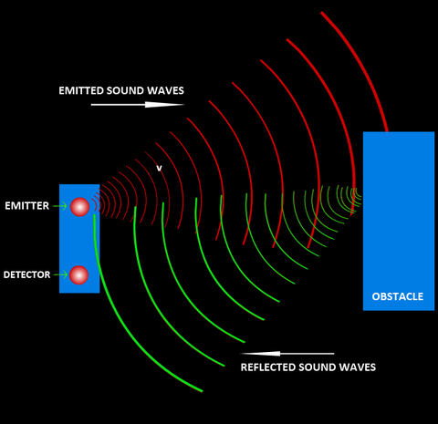

*Figure 2.1: Ultrasonic sensor (incident and Reflection wave) diagram*

Ultrasonic sensors are used primarily as proximity sensors. They can be found in automobile self-parking technology and anti-collision safety systems. Ultrasonic sensors are also used in robotic obstacle detection systems, as well as manufacturing technology. In comparison to infrared (IR) sensors in proximity sensing applications, ultrasonic sensors are not as susceptible to interference of smoke, gas, and other airborne particles (though the physical components are still affected by variables such as heat).

Ultrasonic sensors are also used as level sensors to detect, monitor, and regulate liquid levels in closed containers (such as vats in chemical factories). Most notably, ultrasonic technology has enabled the medical industry to produce images of internal organs, identify tumors, and ensure the health of babies in the womb.

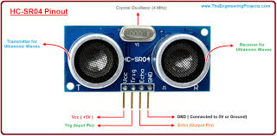

*Figure 2.2: Diagram of the Ultrasonic sensor*

## 2.4 The Microcontroller for Distance Measurement

The Arduino Nano is a small, complete, and breadboard-friendly board based on the ATmega328 (Arduino Nano 3.x). It has more or less the same functionality of the Arduino Duemilanove, but in a different package. It lacks only a DC power jack, and works with a Mini-B USB cable instead of a standard one.

Power

The Arduino Nano can be powered via the Mini-B USB connection, 6-20V unregulated external power supply (pin 30), or 5V regulated external power supply (pin 27). The power source is automatically selected to the highest voltage source.

Memory

The ATmega328 has 32 KB, (also with 2 KB used for the bootloader. The ATmega328 has 2 KB of SRAM and 1 KB of EEPROM.

Input and Output

Each of the 14 digital pins on the Nano can be used as an input or output, using pinMode(), digitalWrite(), and digitalRead() functions. They operate at 5 volts. Each pin can provide or receive a maximum of 40 mA and has an internal pull-up resistor (disconnected by default) of 20-50 kOhms. In addition, some pins have specialized functions:

Serial: 0 (RX) and 1 (TX). Used to receive (RX) and transmit (TX) TTL serial data. These pins are connected to the corresponding pins of the FTDI USB-to-TTL Serial chip.

External Interrupts: 2 and 3. These pins can be configured to trigger an interrupt on a low value, a rising or falling edge, or a change in value. See the attachInterrupt() function for details.

PWM: 3, 5, 6, 9, 10, and 11. Provide 8-bit PWM output with the analogWrite() function.

SPI: 10 (SS), 11 (MOSI), 12 (MISO), 13 (SCK). These pins support SPI communication, which, although provided by the underlying hardware, is not currently included in the Arduino Language.

### 2.4.1 Communication

The Arduino Nano has a number of facilities for communicating with a computer, another Arduino, or other microcontrollers. The ATmega328 provide UART TTL (5V) serial communication, which is available on digital pins 0 (RX) and 1 (TX). An FTDI FT232RL on the board channels this serial communication over USB and the FTDI drivers (included with the Arduino software) provide a virtual com port to software on the computer. The Arduino software includes a serial monitor which allows simple textual data to be sent to and from the Arduino board. The RX and TX LEDs on the board will flash when data is being transmitted via the FTDI chip and USB connection to the computer (but not for serial communication on pins 0 and 1).

A SoftwareSerial library allows for serial communication on any of the Nano's digital pins.

The ATmega328 also support I2C (TWI) and SPI communication. The Arduino software includes a Wire library to simplify use of the I2C bus. To use the SPI communication, please see ATmega328 datasheet.

### 2.4.2Programming

The Arduino Nano can be programmed with the Arduino software (download). Select "Arduino Duemilanove or Nano w/ ATmega328" from the Tools > Board menu (according to the microcontroller on your board).

The ATmega328 on the Arduino Nano comes pre burned with a bootloader that allows you to upload new code to it without the use of an external hardware programmer. It communicates using the original STK500 protocol.

You can also bypass the bootloader and program the microcontroller through the ICSP (In-Circuit Serial Programming) header using Arduino ISP or similar.

### 2.4.3 Automatic (Software) Reset

Rather than requiring a physical press of the reset button before an upload, the Arduino Nano is designed in a way that allows it to be reset by software running on a connected computer. One of the hardware flow control lines (DTR) of the FT232RL is connected to the reset line of the ATmega328 via a 100 nanofarad capacitor. When this line is asserted (taken low), the reset line drops long enough to reset the chip. The Arduino software uses this capability to allow you to upload code by simply pressing the upload button in the Arduino environment. This means that the bootloader can have a shorter timeout, as the lowering of DTR can be well-coordinated with the start of the upload.

This setup has other implications. When the Nano is connected to either a computer running Mac OS X or Linux, it resets each time a connection is made to it from software (via USB). For the following half-second or so, the bootloader is running on the Nano. While it is programmed to ignore malformed data (i.e. anything besides an upload of new code), it will intercept the first few bytes of data sent to the board after a connection is opened. If a sketch running on the board receives one-time configuration or other data when it first starts, make sure that the software with which it communicates waits a second after opening the connection and before sending this data.

## 2.5 The Display

LCD modules are very commonly used in most embedded projects, the reason being its cheap price, availability and programmer friendly. Most of us would have come across these displays in our day to day life, either at PCO’s or calculators. The appearance and the pinouts have already been visualized above now let us get a bit technical.

16×2 LCD is named so because; it has 16 Columns and 2 Rows. There are a lot of combinations available like, 8×1, 8×2, 10×2, 16×1, etc. but the most used one is the 16×2 LCD. So, it will have (16×2=32) 32 characters in total and each character will be made of 5×8 Pixel Dots. A Single character with all its Pixels is shown in the below picture.

Now, we know that each character has (5×8=40) 40 Pixels and for 32 Characters we will have (32×40) 1280 Pixels. Further, the LCD should also be instructed about the Position of the Pixels. Hence it will be a hectic task to handle everything with the help of MCU, hence an Interface IC like HD44780is used, which is mounted on the backside of the LCD Module itself. The function of this IC is to get the Commands and Data from the MCU and process them to display meaningful information onto our LCD Screen. You can learn how to interface an LCD using the above-mentioned links. If you are an advanced programmer and would like to create your own library for interfacing your Microcontroller with this LCD module then you have to understand the HD44780 IC is working and commands which can be found its datasheet.

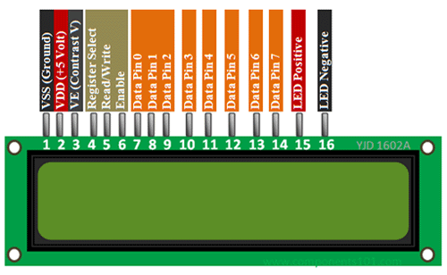

*Figure 2.3: The lcd display connections*

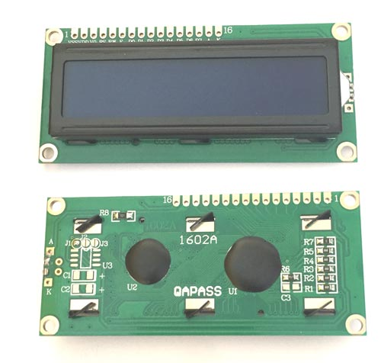

*Figure 2.4: The LCD features*

**CHAPTER THREE**

**SYSTEM DESIGN AND ANALYSIS**

**3.1 Materials**

The materials use in the project are listed on table 3.1 below

Table 3.1: List of components

|  |  |  |  |
| --- | --- | --- | --- |
| S/N | Component | Label/Value | Quantity |
| 1 | Microcontroller | Arduino ATtiny | 1 |
| 2 | Ultrasonic sensor | HSR 04 | 1 |
| 3 | Light emitting diode | Red led | 1 |
| 4 | Display | 16*2 LCD | 1 |
| 5 | 9.0v battery | 9.0v pp3 | 1 |
| 6 | 5.0v Regulator | 7805 | 1 |
| 7 | Single pole switch | S1 | 1 |

## 3.2 Methods

In actualizing this project, the design summarized in the block diagram of figure 3.2 was employed.

Arduino Microcontroller

LCD Display

Ultrasonic Sensor

Power supply

*Figure 3.1: Block diagram of the ultrasonic distance meter*

## 3.3 The Microcontroller

The microcontroller employed in this design is an ATtiny13 microcontroller. This controller comprises of an ATMEGA328p chip and is capable of Universal Synchronous, Asynchronous Receiver Transmitter (USART) communication. The Arduino microcontroller was used in this design because of the relative ease of programming and also because of its teaming community available online. The community provides assistance to difficulties encountered in programming the controller.

## 3.4 The Display

To be able to see the data detected and calculated values, a 16X2 LCD display is chosen. The display is capable of displaying two rows of data at the same time.

## 3.5 The Sensor

Ultrasonic ranging module HC - SR04 provides 2cm - 400cm non-contact measurement function, the ranging accuracy can reach to 3mm. The modules include ultrasonic transmitters, receiver and control circuit. The basic principle of work: (1) Using IO trigger for at least 10us high level signal, (2) The Module automatically sends eight 40 kHz and detect whether there is a pulse signal back. (3) IF the signal back, through high level, time of high output IO duration is the time from sending ultrasonic to returning. Test distance = (high level time × velocity of sound (340M/S) / 2.

## 3.6 Principle of Operation

The sound signal sent by the transmitting part of the sensor gets echoed back to the receiving part of the sensor. The microcontroller is programmed in C++ to calculate The time taken by the waves to travel to the obstruction and back is calculated by the microcontroller and display the result on the LCD screen in centimeters.



*Figure 3.2: Complete Circuit Diagram*

## 3.7 Construction

### 3.7.1 Bread boarding

A breadboard is a rectangular plastic board with a bunch of tiny holes in it. These holes let you easily insert electronic components to prototype (meaning to build and test an early version of) an electronic circuit. The connections are not permanent, so it is easy to *remove* a component if you make a mistake, or just start over and do a new project. Technically, these breadboards are called solderless breadboards because they do not require soldering to make connections. Soldering (pronounced SAW-der-in).

Bread boarding is a method where electronic components are joined together by melting a special type of metal called solder to give the two components an electrical connection.

Once inserted that component will be electrically connected to anything else placed in that row. This is because the metal rows are conductive and allow current to flow from any point in that strip.

The components are laid on the breadboard following the schematic diagram of the project as shown in figure 3.3

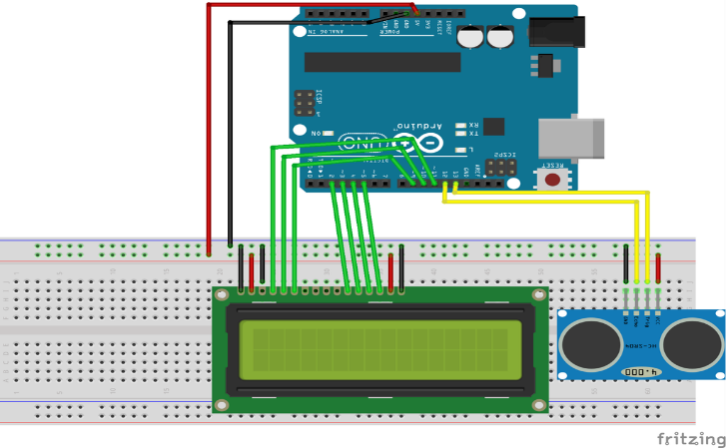

*Figure 3.3: Breadboard Layout*

### 3.7.2 Soldering

Soldering is a joining process used to join different types of metals together by melting solder. Solder is a metal alloy usually made of tin and lead which is melted using a hot iron. The iron is heated to temperatures above 600 degrees Fahrenheit which then cools to create a strong electrical bond. Solder is melted by using heat from an iron connected to a temperature controller. It is heated up to temperatures beyond its melting point at around 600 degrees Fahrenheit which then causes it to melt, which then cools creating the soldered joint, as well as creating strong electrical joints solder can also be removed using a de-soldering tool. A solder is a metal alloy used to create strong permanent bonds; such as copper joining in circuit boards and copper pipe joints. It can also be supplied in two different types and diameters, lead and lead free and also can be between .032” and .062”. Inside the solder core is the flux, a material used to strengthen and improve its mechanical properties.

The type of soldering employed is Soft soldering (90 °C - 450 °C) - This process has the lowest filler metal melting point of all the soldering types at less than around 400°C these filler metals are usually alloys, often containing lead with liquidus temperatures under 350°C. Because of the low temperatures used in soft soldering it thermally stresses components the least but does not make strong joints and is then therefore unsuitable for mechanical load-bearing applications. It is also not suited for high temperature use as this type of solder loses strength and melts.

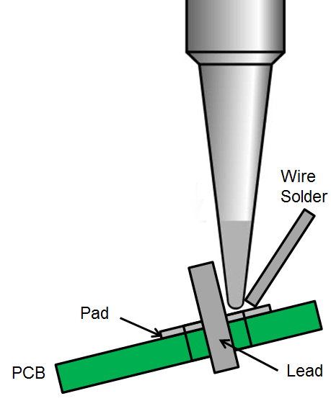

*Figure 3.4: Soldering*

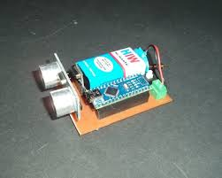

*Figure 3.5: the soldered circuit*

## 3.8 Testing

And after soldering the circuit was also tested unit by unit to make sure there was no any short or open circuit.

Test on the constructed circuit was done in three ways, visual, with a meter and functional

Visual tests were done as to check if all connections are done correctly and if there are any short or open circuits on the board, this is done without applying power to the circuit.

The second test is done after powering the circuit, a digital meter is set at continuity and then voltage range to check for polarity of supply, correct voltage levels across and between components.

The last tests were done on the functional circuit to establish if it can sense and determine the distance between the sensor and an obstacle at which it is pointed.

### 3.8.1 Component Testing

This section deals with how the system components were individually tested before the construction and how the finalized circuit was tested.

### 3.8.2 Complete Prototype Testing

The following procedure is used in carrying out test on the constructed system. The device was powered ON subjected to various levels of obstruction at various distances of generation from the sensor. The result was recorded and tabulated in table 4.1

1. Circuit powered ON
2. Peron made to walk toward the sensor repeatedly at different distance from the sensor.

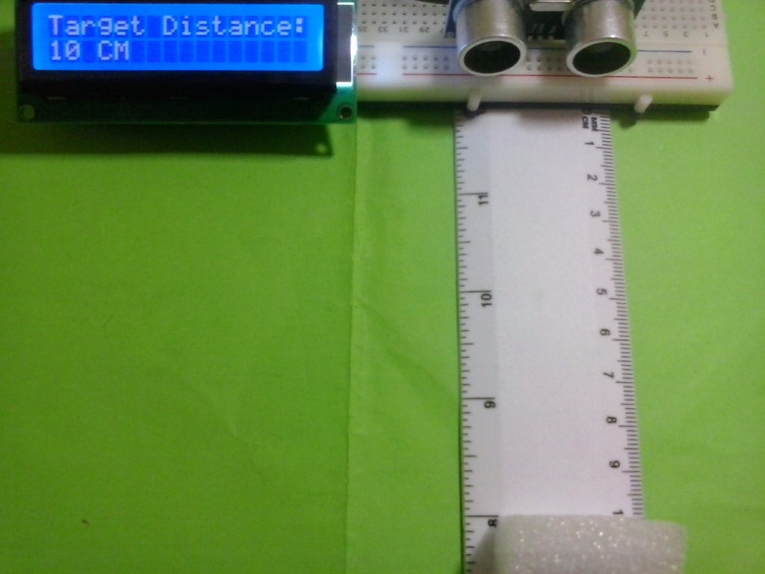

*Figure 3.6: The prototype test Setup*

# CHAPTER FOUR

# TESTING, RESULT AND DISCUSSION

## 4.1 Result

Table 4.1: Component Test Result

|  |  |  |  |  |
| --- | --- | --- | --- | --- |
| S/N | Component | Type of Test | Test Tool | Result |
| 1 | Fixed resistors | Resistance | Ohmmeter | Ok within +/- 10% |
| 2 | Buzzer | Applied Voltage | 12V DC power Supply | Ok |
| 3 | LED | Applied Voltage | 3V DC power Supply | OK |
| 4 | Battery | Volt metering | Voltmeter | 12V |
| 5  6 | Switch  Capacitors | Continuity  Capacitance | Continuity Checker  Capacitance meter | Continuous when closed  All ok |

Table 4.2: Result of Measurement with Ruler/3m Tape

|  |  |  |  |  |
| --- | --- | --- | --- | --- |
| S/N | Ruler Measurement (cm) | 3m Tape measurement (cm) | Difference (cm) | |
| 1 | 50.00 | 50.70 | | 0.7 |
| 2 | 60.00 | 60.20 | | 0.2 |
| 3 | 70.00 | 71.10 | | 1.1 |
| 4 | 80.00 | 80.33 | | 0.33 |
| 5 | 90.00 | 90.40 | | 0.40 |
| 6 | 100.00 | 100.10 | | 0.10 |
| 7 | 150.00 | 151.10 | | 1.1 |
| 8 | 200.00 | 200.40 | | 0.40 |
| 9 | 250.00 | 250.31 | | 0.31 |
| 10 | 300.00 | 300.12 | | 0.12 |

## 4.2 Discussion

Static test results tabulated on table 4.1 show that the components used in the construction area all in good condition., buzzer produced the alarm sound when powered by applying 12V across its terminals. The LED also emitted light when 3V was applied across its terminals. The Battery had a no-load potential of 12.40V Dc as measured by the voltmeter, the switch was checked with a continuity checker which showed that it was ok, the resistor all have values within +/- 10% as marked on their frames, the capacitors were all in good condition.

The results shown in tables 4.2 show that the constructed 3m tape can measure distance just as well as the rule, however there are differences in the obtained readings. The maximum difference or deviation was when the rule was used to measure 70cm, the 3m tape gave 71.1 with a difference of 1.1cm. the minimum difference was obtained when the rule was used to 100cm, the 3m tape gave 100.1cm with a deviation of 0.1cm. The determined total average deviations was 0.44cm which is less than 1%. The deviations are mainly due to parallax error when reading the rule used and the calibration error in the division of the rule segments from manufacture.

Table 4.3: Bill of Engineering Measurement and Evaluation (BEME)

|  |  |  |  |  |
| --- | --- | --- | --- | --- |
| S/N | Description | Quantity | Unit price | Amount |
| 1 | 2 x 16 LCD | 1 | 3000 | 3000 |
| 2 | Arduino microcontroller | 1 | 5500 | 5500 |
| 3 | Jumper wires | 1 | 150 | 150 |
| 4 | Vero board | 1 | 300 | 300 |
| 5 | Connecting wires |  | 150 | 150 |
| 6 | PVC plastic case | 1 | 1500 | 1500 |
| 7 | Glue | 1 | 500 | 500 |
| 8 | Ultrasonic sensor | 1 | 2500 | 2000 |
| 9 | 9v battery | 1 | 250 | 250 |
| 10 | Screws | 10 | 10 | 100 |
| 11 | Switch | 1 | 150 | 150 |
|  | **Total cost =** |  |  | **N14,250** |

# CHAPTER FIVE

# SUMMARY, CONCLUSION AND RECOMMENDATIONS

## 5.1 Summary

In a summary, the aim of this project is to design and construct a suitable electronic digital distance measuring device as a 3m tape. The power supply unit, distance detector unit, signals conditioning, processing unit and display unit has been designed, tested and coupled together. The coupled system has been constructed and used to carry out some measurement in comparison to a measuring tape can measure.

The effective operation of the project and performance is dependent on the user who is prone to human error.

## 5.2 Conclusion

The project which is the design and construction of a Digital Distance Measuring Device was designed considering some factors such as economy, availability of components and research materials, efficiency, compatibility and portability and also durability. The performance of the project after test met design specifications. The project has really exposed me to hardware programming of micro-controllers and practical electronics generally. The design of the digital distance measuring device involved research in micro-controllers programming. Intensive work was done on C++ language programming and the packaging as well. The project was quite challenging and tedious but eventually was a success.

However, like every aspect of engineering there is still room for improvement and further research on the project as suggested in the recommendations.

## 5.3 Recommendations

I would recommend that further work be done on the following area

1. Further work should be concentrated on the circuit cards, putting into close consideration the use of printed circuit boards (PCB).
2. A software model of the design should be done to enable further research and improve the performance of the system. i.e., such software that will convert the number of revolutions to distance.
3. Other sensor should be tried to improve on the distance and accuracy
4. The department should give out project titles on schedule to enable student prepare well for the work on project.

# REFERENCES

Crease, D. (2012). *American journal of science*. Note on progress of experiments for comparing a wavelength with a meter. P.203

Mohammed, T. (2015). *Design And Construction of a Burglary Alarm System*. Repository.mouau.ed. Repository.mouau.edu.ng, 05 Jul. 2021, https://repository.mouau.edu.ng [/work/view/design-andconstruction-](https://repository.mouau.edu.ng/work/view/design-andconstruction-) of-a-burglary-alarm-system-7-2. Accessed 04 Mar. 2022.

Kirch, V. & Wilhelm, K. (2008). *Encyclopedia of measurement.* Level of measurement encyclopedia of public health. Pp. 81

Monsha, B. & Matthias, B. (2012). "Growing Tall: Anthropometric Welfare of World Regions and its Determinants, 1810-1989". Economic History of Developing Regions. 27. doi:10.1080/20780389.2012.657489. S2CID 154506540 –via Researchgate. -sensor#: ~:text=An%20ultrasonic%20senso

Morris, V. (2011).Design & Development of Smart Ultrasonic Distance Measuring Device, *International, journal of ultrasonic sensors, ultrasonic symposium.* Vol. 1 Pp. 471-481. Nov.3, 1994.

Pedhazur L. & Elezar J. (2019). Measurement design and analysis: an integrated approach.*International Journal of Innovative Research in Electronics and Communications (IJIREC),* Pp. 15-29.

Prakhar, K & Jane, P. (2014). Design and construction of a simple height measuring device. *Applied technology Journal.* 12(34), 23-27.www.ATJ.com/jour/update/rr-89.

Shamshul S. M, (2013). *Measurement and instrumentation principles.* New Delhi. British library cataloguing in publication data.

# APPENDIX

**The Program Code**

#include <LiquidCrystal.h> --- This line includes a library of instructions from the Arduino

database

#define trigger 18

#define echo 19 --- this lines instruct the Arduino to take pin 18 as trigger input from the

sensor and pin 19 as echo signal input to the arduino

LiquidCrystal lcd(2,3,4,5,6,7) ; --- this line defines the pins the microcontroller uses to

address the lcd display

void setup() ---The following lines set up the LCD and instructions to display

lcd.begin(16,2);

pinMode(trigger,OUTPUT);

pinMode(echo,INPUT);

lcd.print(" Ultra sonic");

lcd.setCursor(0,1);

lcd.print("Distance Meter");

delay(2000);

lcd.clear();

lcd.print(" Circuit Digest");

delay(2000);

void loop() --- The following lines perform the data manipulation to calculate

the distance

lcd.clear();

digitalWrite(trigger,LOW);

delayMicroseconds(2);

digitalWrite(trigger,HIGH);

delayMicroseconds(10);

digitalWrite(trigger,LOW);

delayMicroseconds(2);

time=pulseIn(echo,HIGH);

distance=time*340/20000;

lcd.clear();

lcd.print("Distance:");

lcd.print(distance);

lcd.print("cm");

lcd.setCursor(0,1);

lcd.print("Distance:");

lcd.print(distance/100);

lcd.print("m");

delay (1000);